

# INSTITUTE OF ECE ECA14 – EMBEDDED SYSTEMS

**List of Experiments**

|  |  |  |
| --- | --- | --- |
| **Exp. No** | **Name of the Experiment** | **Remarks** |
| **1** | Study of Proteus Micro Vision |  |
| **2** | Flashing of Led using AT89C51 Microcontroller using Proteus |  |
| **3** | Generation of Square Wave using Proteus |  |
| **4** | Smooth Brightness Change of Led using AT89C51 using  Proteus |  |
| **5** | Stepper Motor Using AT89C51 using Proteus |  |
| **6** | Interfacing of Relay Using AT89C51 using Proteus |  |
| **7** | Led Toggle Using AT89C51 using Proteus |  |
| **8** | 7 Segment Display Using AT89C51 using Proteus |  |
| **9** | LED Chaser Using AT89C51 using Proteus |  |
| **10** | Arduino based Manual Electronic Counter using Proteus |  |
| **11** | Arduino to 16x2 LCD Display using Proteus |  |
| **12** | Serial Communication using Arduino with Proteus |  |
| **13** | Temperature Sensor in Proteus using Arduino |  |
| **14** | Gas Sensor MQ-2 in Proteus using Arduino |  |
| **15** | Ultrasonic Sensor in Proteus using Arduino |  |
| **16** | PIR Sensor in Proteus using Arduino |  |
| **17** | Embedded C program to multiply two 16-bit binary numbers. |  |
| **18** | Embedded C program to find the sum of first 10 integer  numbers. |  |
| **19** | Embedded C program to find factorial of a given numbers. |  |

|  |  |  |
| --- | --- | --- |
| **20** | Embedded C program to add an array of 16-bit numbers and  store the 32-bit result in internal RAM. |  |
| **21** | Embedded C program to display “Hello World” message |  |
| **22** | Embedded C program to convert the hexadecimal data 0xCFh to decimal and display the digits on ports P0, P1 and P2 (port  window in simulator). |  |
| **23** | Study of ARM Processor |  |
| **24** | Blinking LEDs using software delay routine in LPC2148 kit |  |
| **25** | Program to read the switch and display in the LEDs using  LPC2148 kit |  |
| **26** | Display a number in seven segment LED in LPC2148 kit |  |
| **27** | Serial transmission and reception using on-chip UART in  LPC2148 kit |  |
| **28** | Access an internal ADC and display the binary output in LEDs  in LPC2148 kit |  |

**Exp No: 1**

# STUDY OF PROTEUS AND KEIL MICRO VISION

**AIM:** To study the working procedures of Proteus and Keil Micro vision software.

**Keil Micro Vision** is a free software which solves many of the main points for an embedded program developer. This software is an integrated development environment (IDE), which integrated a text editor to write programs, a compiler and it will convert your source code to hex files too. μVision4 introduces a flexible window management system, enabling us to drag and drop individual windows anywhere on the visual surface including support for Multiple Monitors.

# KEIL PROCEDURE:

1. Open the software, Click on project and open new version project.
2. Create a new project file
3. Enter AT89C51
4. Click NO
5. Click [Ctrl +N] and Type the code
6. Open project and click Build target
7. Open Build target and open source file and ADD, CLOSE
8. Click build target
9. Next debug start and stop
10. Open peripherals and select port 2
11. Now run the program in Debug
12. Open project and click optional properties and in that give output as hex file.
13. Create hex file.

# PROTEUS PROCEDURE:

* + Open proteus by clicking run as administrator.
  + Open new project and enter the file name.
  + Click next, next, next and finish.
  + Click P symbol and search keyword and place the required components
  + Now connect the components as required
  + Give input to AT89C51 as HEX file.
  + Start the simulation process

**RESULT:** Thus the Proteus and Keil Micro vision software were studied.

**Exp No: 2**

# FLASHING OF LED USING AT89C51 MICROCONTROLLER USING PROTEUS

**AIM:**

To Write an assembly language program to flash the LED using AT89C51

# SOFTWARES REQUIRED:

* Proteus software

# PROGRAM

ORG 0000H UP: SETB P2.0

ACALL DELAY CLR P2.0 ACALL DELAY SJMP UP

DELAY: MOV R4,#35 H1:MOV R3,#255 H2:DJNZ R3,H2

DJNZ R4,H1 RET

END

# CIRCUIT DIAGRAM:

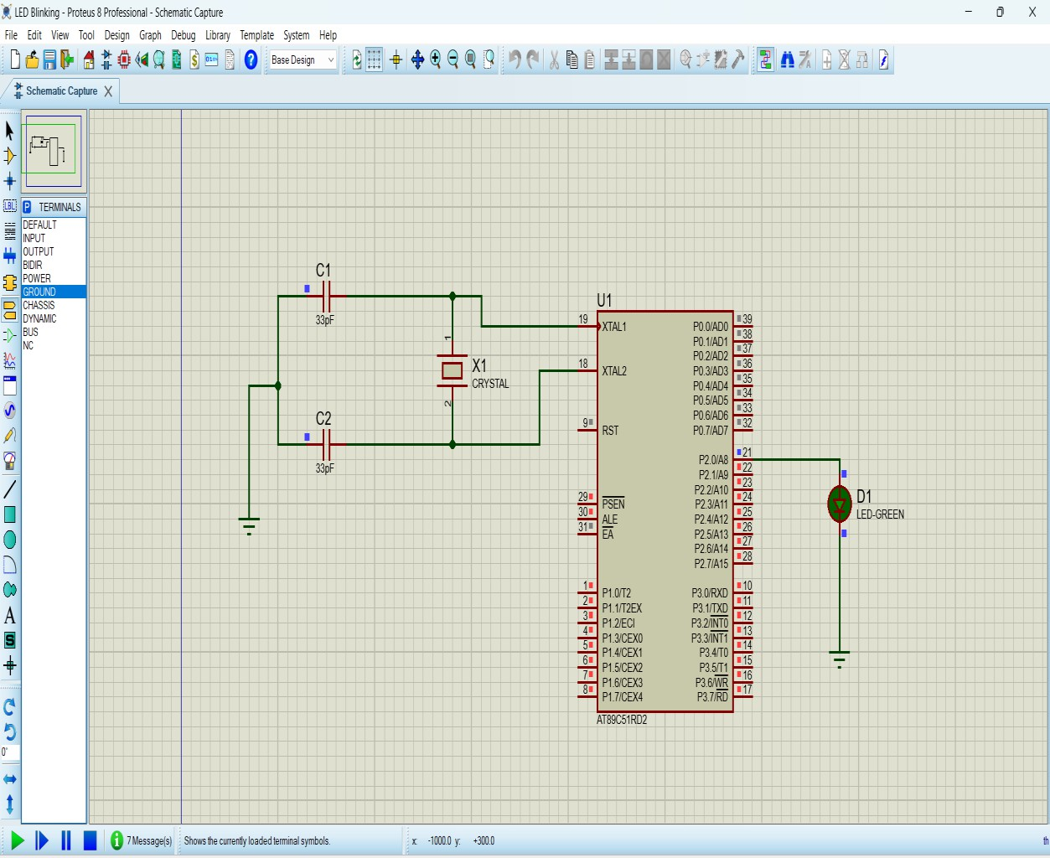

**RESULT**

Thus the program has been successfully verified and executed.

**Exp No: 3**

# AIM:

# GENERATION OF SQUARE WAVE USING PROTEUS

To write an assembly language program to Generate square wave using AT89C51.

# SOFTWARE REQUIRED:

* Proteus 8 software.

# PROGRAM

ORG 0000H UP: SETB P2.0

ACALL DELAY CLR P2.0 ACALL DELAY SJMP UP

DELAY: MOV R4,#35 H1:MOV R3,#255 H2:DJNZ R3,H2

DJNZ R4,H1 RET

END

**CIRCUIT DIAGRAM:**

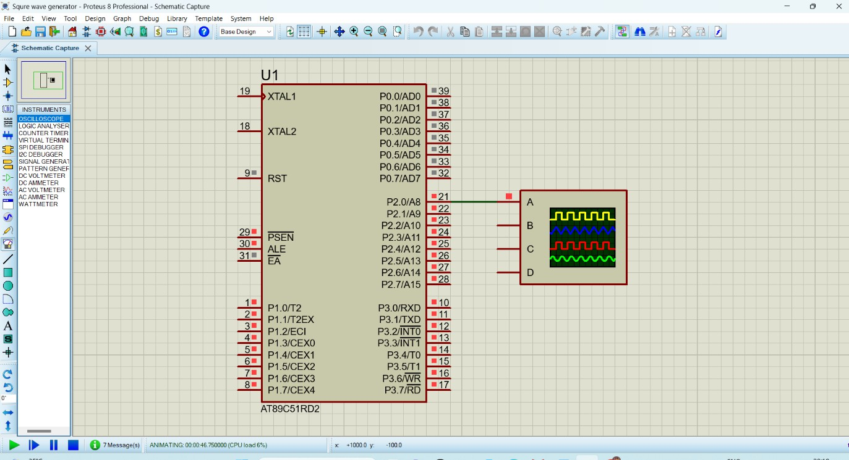

**OUTPUT:**

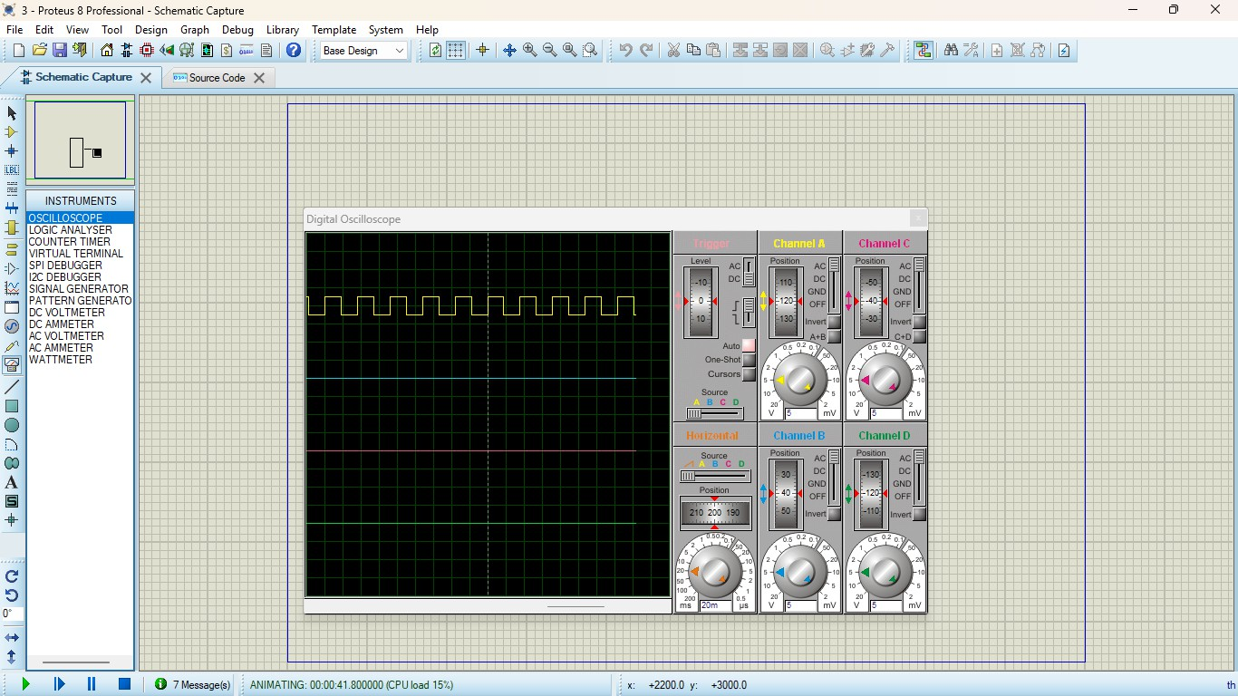

**RESULT:**

Thus the program has been successfully verified and executed.

**Exp No: 4**

# SMOOTH BRIGHTNESS CHANGE OF LED USING AT89C51 USING PROTEUS

**AIM:**

To write an assembly language program for Fade in Fade out of LED Using AT89C51 using Keil and Proteus

**SOFTWARE REQUIRED:**

* Proteus 8 software.

# PROGRAM:

#include <REGX52.h> delay(unsigned int y)

{

unsigned int i,j; for(i=0;i<y;i++)

{

for(j=0;j<1275;j++){}

}

}

main()

{

while(1)

{

delay(100); P1_0 = 0;

delay(100); P1_0 = 1;

}

}

# CIRCUIT DIAGRAM:

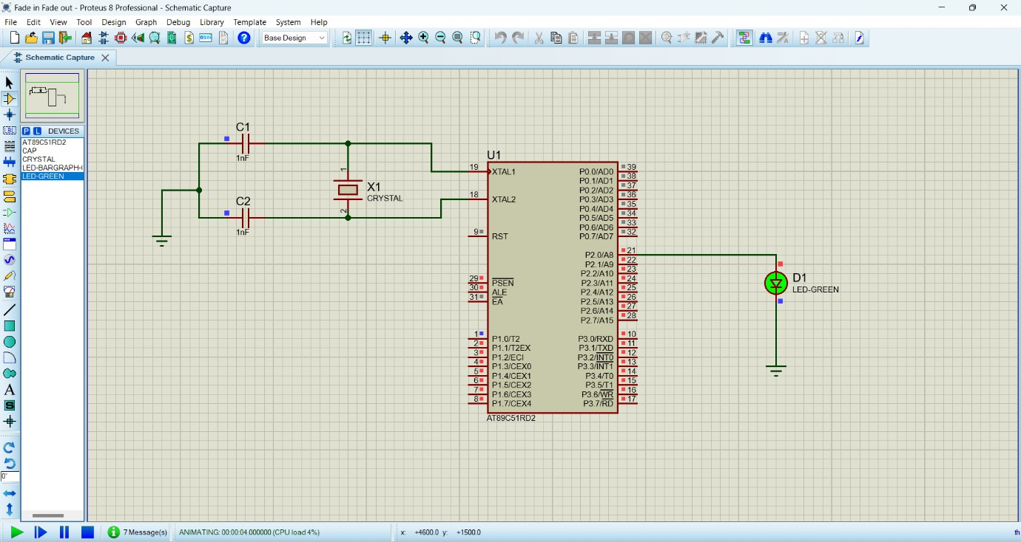

**RESULT:**

Thus the program has been successfully verified and executed.

**Exp No: 5**

# AIM:

# STEPPER MOTOR USING AT89C51 USING PROTEUS

To write an assembly language program for Stepper Motor Using AT89C51 using Keil and Proteus

**SOFTWARE REQUIRED:**

* Proteus 8 software.

# PROGRAM:

ORG 0000H

UP: MOV P2,#09H ACALL DELAY MOV P2,#0CH ACALL DELAY MOV P2,#06H ACALL DELAY MOV P2,#03H ACALL DELAY SJMP UP DELAY:MOV R4,#18 H1:MOV R3,#255 H2:DJNZ R3,H2 DJNZ R4,H1

RET END

# CIRCUIT DIAGRAM:

**RESULT:**

Thus the program has been successfully verified and executed.

**Exp No: 6**

# AIM:

# INTERFACING OF RELAY USING AT89C51 USING PROTEUS

To write an assembly language program for Interfacing of Relay Using AT89C51 using Keil and Proteus

**SOFTWARE REQUIRED:**

* Proteus 8 software.

# PROGRAM:

ORG 0000H UP:SETB P2.0 ACALL DELAY CLR P2.0 ACALL DELAY SJMP UP

DELAY:MOV R4,#18 H1:MOV R3,#255 H2:DJNZ R3,H2 DJNZ R4,H1

RET END

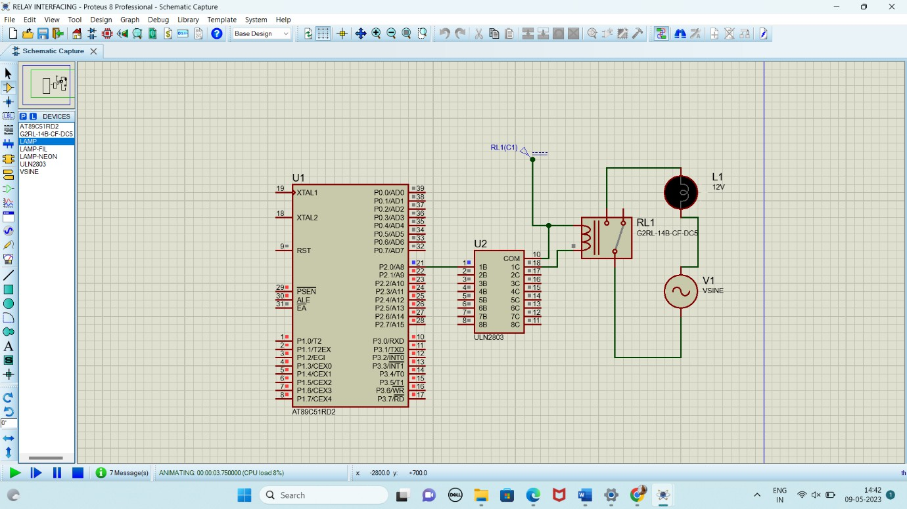**CIRCUIT DIAGRAM:**

**OUTPUT:**

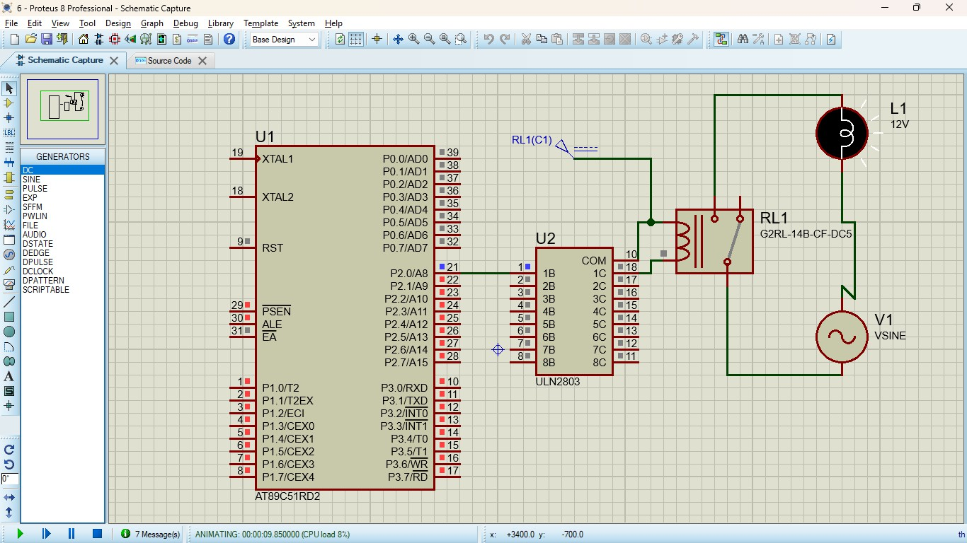

**RESULT:**

Thus the program has been successfully verified and executed.

**Exp No: 7**

# AIM:

# LED TOGGLE USING AT89C51 USING PROTEUS

To write an assembly language program for LED Toggle Using AT89C51 using Keil and Proteus

**SOFTWARE REQUIRED:**

* Proteus 8 software.

# PROGRAM:

ORG 0000H

UP: MOV P2,#55H ACALL DELAY MOV P2,#0AAH ACALL DELAY SJMP UP

DELAY:MOV R4,#10 H1:MOV R3,#255 H2:DJNZ R3,H2 DJNZ R4,H1

RET END

# CIRCUIT DIAGRAM:

**RESULT:**

Thus the program has been successfully verified and executed.

**Exp No: 8**

# 7 SEGMENT DISPLAY USING AT89C51 USING PROTEUS

**AIM:**

To write an assembly language program for 7 Segment Display Using AT89C51 using Keil and Proteus

**SOFTWARE REQUIRED:**

* Proteus 8 software.

# PROGRAM:

ORG 000H UP:MOV P2,#0C0H ACALL DELAY MOV P2,#0F9H ACALL DELAY MOV P2,#0A4H ACALL DELAY MOV P2,#0B0H ACALL DELAY MOV P2,#99H ACALL DELAY MOV P2,#92H ACALL DELAY MOV P2,#82H ACALL DELAY MOV P2,#0F8H ACALL DELAY MOV P2, #80H ACALL DELAY MOV P2,#90H ACALL DELAY

DELAY: MOV R5,#10 H1:MOV R4,#180 H2:MOV R3,#255 H3:DJNZ R3,H3 DJNZ R4,H2

DJNZ R5,H1 RET

END

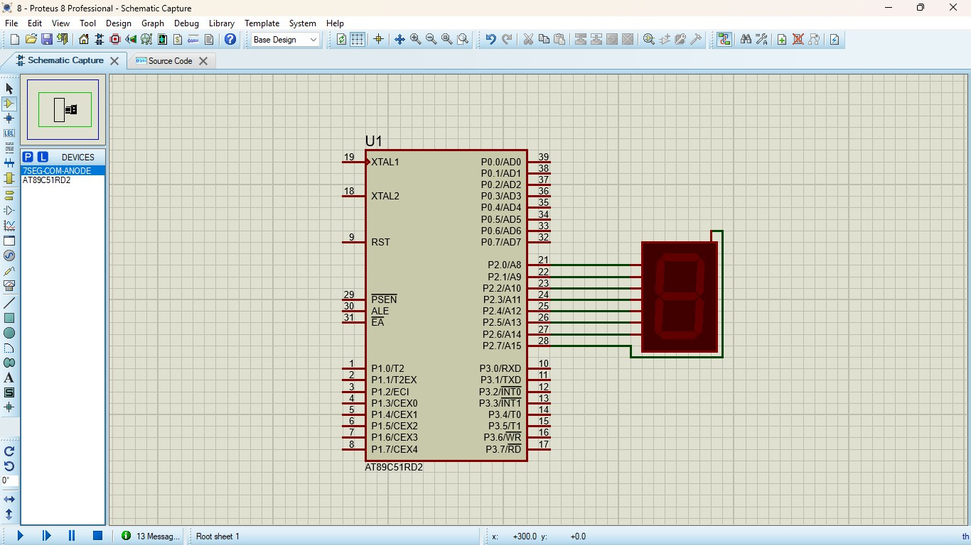**CIRCUIT DIAGRAM:**

**OUTPUT:**

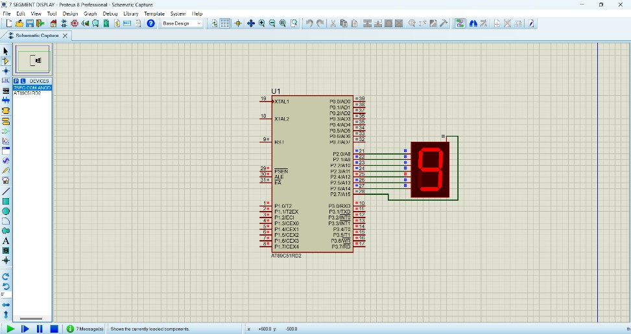

**RESULT:**

Thus the program has been successfully verified and executed.

**Exp No: 9**

# AIM:

# LED CHASER USING AT89C51 USING PROTEUS

To write an assembly language program for LED Chaser Using AT89C51 using Keil and Proteus

**SOFTWARE REQUIRED:**

* Proteus 8 software.

# PROGRAM:

ORG 0000H

UP: MOV P2,#01H ACALL DELAY MOV P2,#02H ACALL DELAY MOV P2,#04H ACALL DELAY MOV P2,#08H ACALL DELAY MOV P2,#10H ACALL DELAY MOV P2,#20H ACALL DELAY MOV P2,#40H ACALL DELAY MOV P2,#80H ACALL DELAY SJMP UP

DELAY: MOV R4,#255 H1: DJNZ R4,H1

RET END

# CIRCUIT DIAGRAM:

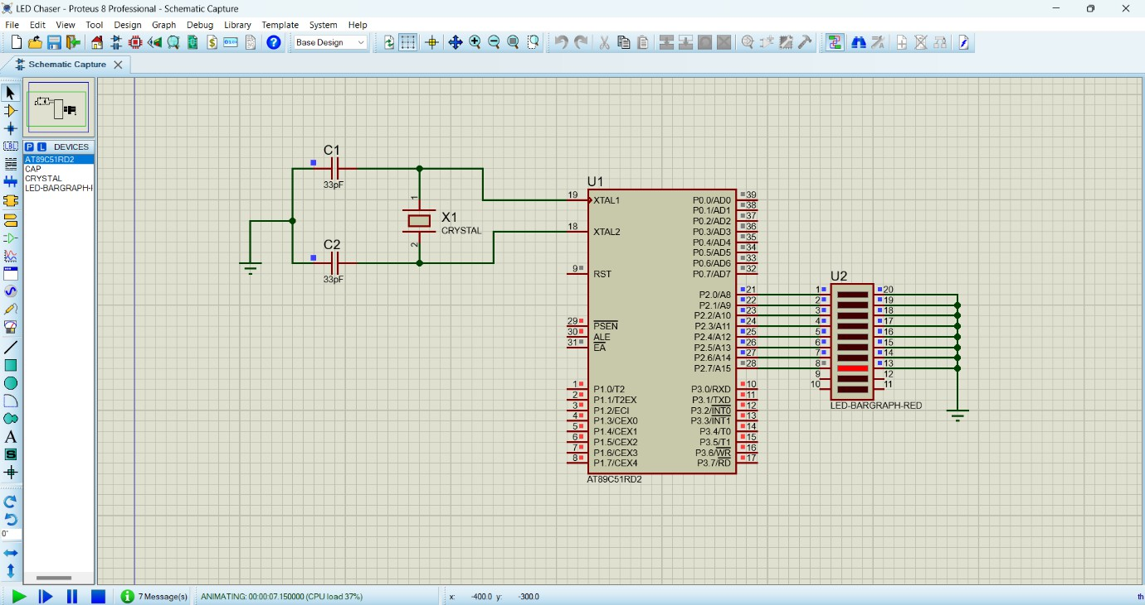

**RESULT:**

Thus the program has been successfully verified and executed.

**Exp No: 10**

# ARDUINO BASED MANUAL ELECTRONIC COUNTER USING PROTEUS

**AIM:**

To write an Embedded C program for Manual Electronic counter using Arduino IDE and Proteus

**SOFTWARE REQUIRED:**

* Proteus 8 software
* Arduino IDE

# CIRCUIT DIAGRAM:

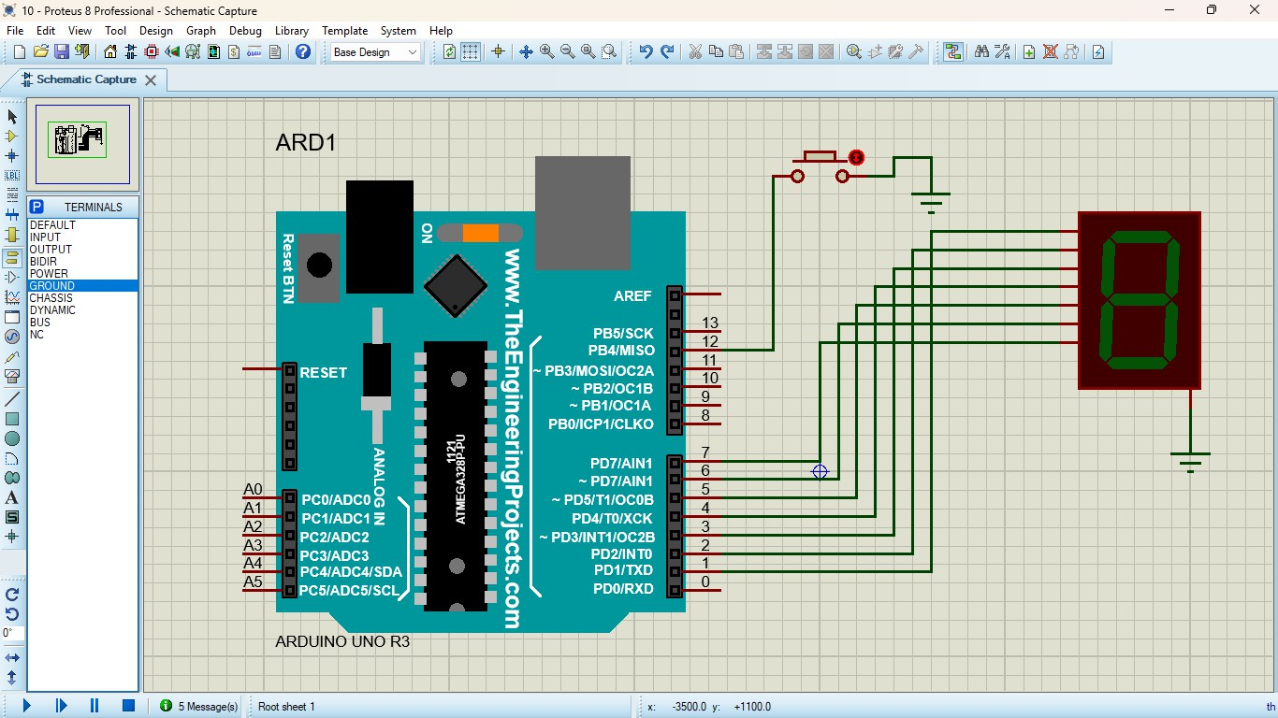

**PROGRAM:**

int x0,x1,x2,x3,x4,x5,x6,x7,x8,x9; int delay_time=200;

void setup() {

//configure pin2 as an input and enable the internal pull-up resistor pinMode(12, INPUT_PULLUP);

pinMode(1,OUTPUT);

pinMode(2,OUTPUT); pinMode(3,OUTPUT); pinMode(4,OUTPUT); pinMode(5,OUTPUT); pinMode(6,OUTPUT); pinMode(7,OUTPUT);

}

void loop() {

//read the pushbutton value into a variable int sensorVal = digitalRead(12);

if (sensorVal == LOW) { x0=true;

}

while(x0){ zero();

sensorVal = digitalRead(12); if (sensorVal == LOW) {

x1=true; x0=false;

}

}

while(x1){ one();

sensorVal = digitalRead(12); if (sensorVal == LOW) {

x2=true; x1=false;

}

}

while(x2){ two();

sensorVal = digitalRead(12); if (sensorVal == LOW) {

x3=true; x2=false;

}

}

while(x3){ three();

sensorVal = digitalRead(12); if (sensorVal == LOW) {

x4=true; x3=false;

}

}

while(x4){ four();

sensorVal = digitalRead(12); if (sensorVal == LOW) {

x5=true; x4=false;

}

}

while(x5){ five();

sensorVal = digitalRead(12); if (sensorVal == LOW) {

x6=true;

x5=false;

}

}

while(x6){ six();

sensorVal = digitalRead(12); if (sensorVal == LOW) {

x7=true; x6=false;

}

}

while(x7){ seven();

sensorVal = digitalRead(12); if (sensorVal == LOW) {

x8=true; x7=false;

}

}

while(x8){ eight();

sensorVal = digitalRead(12); if (sensorVal == LOW) {

x9=true; x8=false;

}

}

while(x9){ nine();

sensorVal = digitalRead(12);

if (sensorVal == LOW) { x0=true;

x9=false;

}

}

}

void zero()

{

for(int i=1;i<7;i++)

{

digitalWrite(i,HIGH); digitalWrite(7,LOW);

}

delay(delay_time);

}

void one()

{

digitalWrite(1,LOW); digitalWrite(2,HIGH); digitalWrite(3,HIGH); digitalWrite(4,LOW); digitalWrite(5,LOW); digitalWrite(6,LOW); digitalWrite(7,LOW); delay(delay_time);

}

void two()

{

digitalWrite(1,HIGH); digitalWrite(2,HIGH); digitalWrite(3,LOW); digitalWrite(4,HIGH); digitalWrite(5,HIGH); digitalWrite(6,LOW); digitalWrite(7,HIGH); delay(delay_time);

}

void three()

{

digitalWrite(1,HIGH); digitalWrite(2,HIGH); digitalWrite(3,HIGH); digitalWrite(4,HIGH); digitalWrite(5,LOW); digitalWrite(6,LOW); digitalWrite(7,HIGH); delay(delay_time);

}

void four()

{

digitalWrite(1,LOW); digitalWrite(2,HIGH); digitalWrite(3,HIGH); digitalWrite(4,LOW);

digitalWrite(5,LOW); digitalWrite(6,HIGH); digitalWrite(7,HIGH); delay(delay_time);

}

void five()

{

digitalWrite(1,HIGH); digitalWrite(2,LOW); digitalWrite(3,HIGH); digitalWrite(4,HIGH); digitalWrite(5,LOW); digitalWrite(6,HIGH); digitalWrite(7,HIGH); delay(delay_time);

}

void six()

{

digitalWrite(1,HIGH); digitalWrite(2,LOW); digitalWrite(3,HIGH); digitalWrite(4,HIGH); digitalWrite(5,HIGH); digitalWrite(6,HIGH); digitalWrite(7,HIGH); delay(delay_time);

}

void seven()

{

digitalWrite(1,HIGH); digitalWrite(2,HIGH); digitalWrite(3,HIGH); digitalWrite(4,LOW); digitalWrite(5,LOW); digitalWrite(6,LOW); digitalWrite(7,LOW); delay(delay_time);

}

void eight()

{

digitalWrite(1,HIGH); digitalWrite(2,HIGH); digitalWrite(3,HIGH); digitalWrite(4,HIGH); digitalWrite(5,HIGH); digitalWrite(6,HIGH); digitalWrite(7,HIGH); delay(delay_time);

}

void nine()

{

digitalWrite(1,HIGH); digitalWrite(2,HIGH); digitalWrite(3,HIGH); digitalWrite(4,HIGH);

digitalWrite(5,LOW); digitalWrite(6,HIGH); digitalWrite(7,HIGH); delay(delay_time);

}

# OUTPUT:

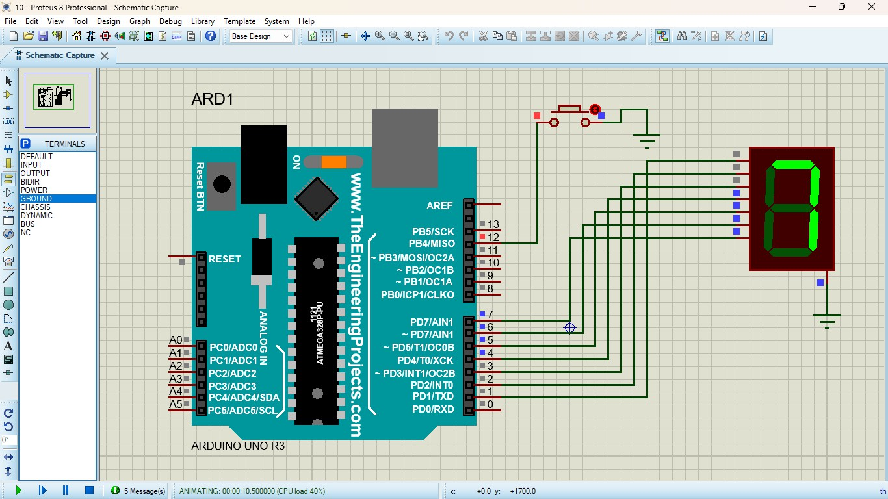

**RESULT:**

Thus the program has been successfully verified and executed.

**Exp No: 11**

# AIM:

**ARDUINO TO 16x2 LCD DISPLAY USING PROTEUS**

To write an Embedded C program to interface Arduino Uno and 16 x 2 LCD display using Arduino Uno and Proteus

**SOFTWARE REQUIRED:**

* Proteus 8 software.
* Arduino IDE software

# CIRCUIT DIAGRAM:

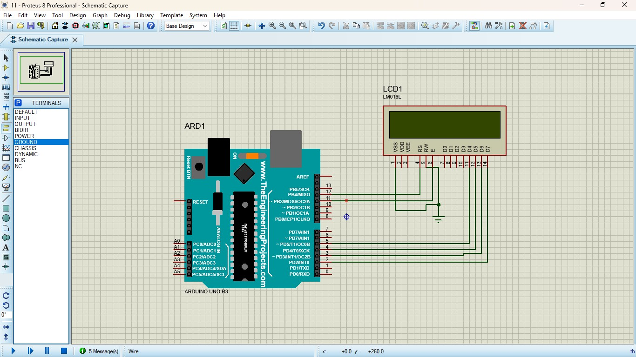

**PROGRAM:**

Arduino to 16x2 LCD Display using Proteus

#include <LiquidCrystal.h> LiquidCrystal lcd (7, 8, 9, 10, 11, 12);

// your PWM numbers may be different void setup() {

lcd.begin(16, 2);

lcd.print("put your message here");

}

void loop () {

for (int i=0; 1<13; i++)

}

lcd.scrollDisplayLeft(); delay(700);

}

}

# OUTPUT:

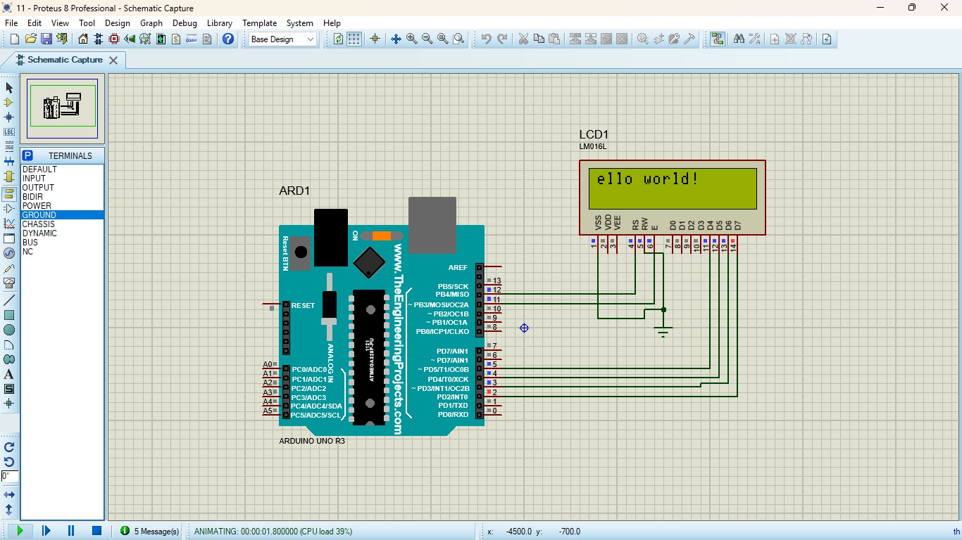

**RESULT:**

Thus the program has been successfully verified and executed.

**Exp No: 12**

# SERIAL COMMUNICATION USING ARDUINO WITH PROTEUS

**AIM:**

To write an Embedded C program for serial communication using Arduino Uno and Proteus

**SOFTWARE REQUIRED:**

* Proteus 8 software.
* Arduino IDE software

# CIRCUIT DIAGRAM:

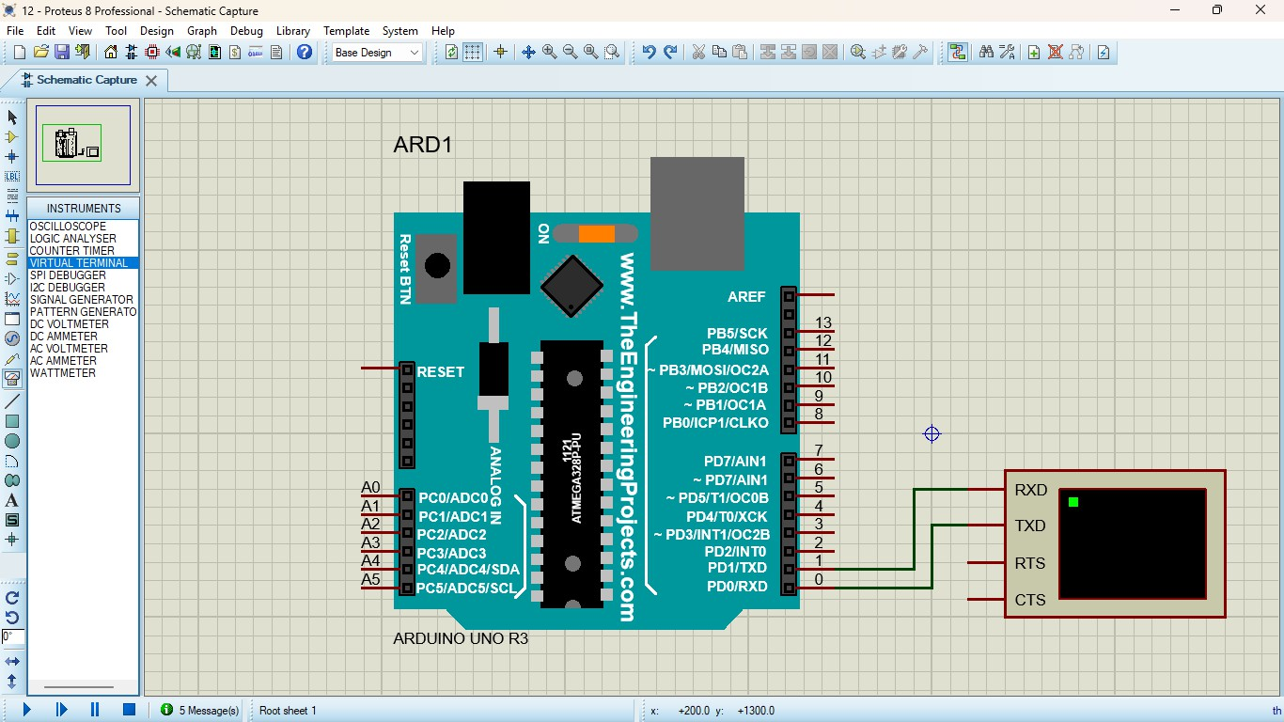

**PROGRAM:**

void setup()

{

Serial.begin(9600); // send and receive at 9600 baud

}

int number = 0;

void loop()

{

Serial.print("Number is "); Serial.println(number); // print the number delay(500); // delay half second between numbers number++; // to the next number

}

# OUTPUT:

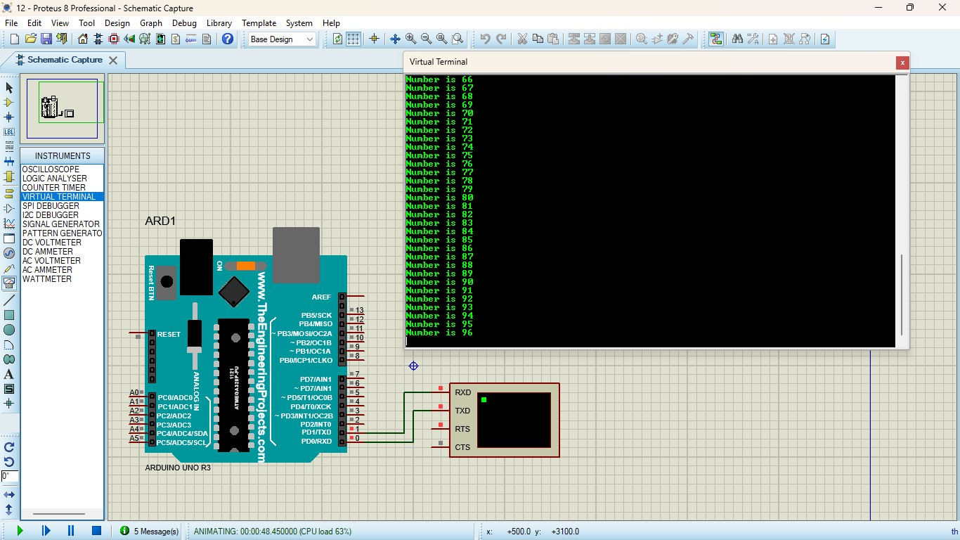

**RESULT:**

Thus the program has been successfully verified and executed.

**Exp No: 13**

# AIM:

# TEMPERATURE SENSOR IN PROTEUS USING ARDUINO

To write an Embedded C program for interfacing Temperature Sensor using Arduino Uno and Proteus

**SOFTWARE REQUIRED:**

* Proteus 8 software.
* Arduino IDE software

# CIRCUIT DIAGRAM:

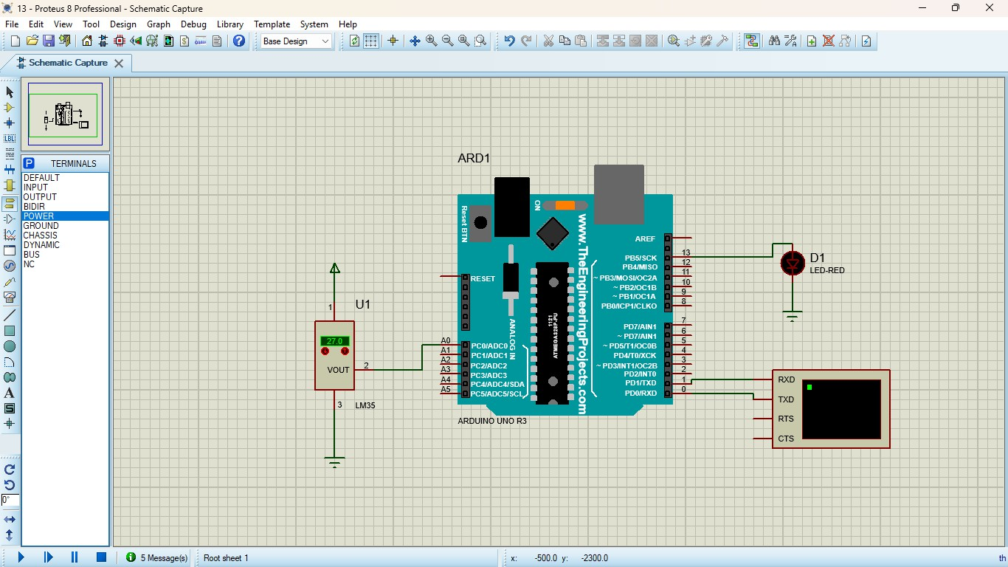

**PROGRAM:**

float temp; void setup() {

pinMode (13, OUTPUT);

Serial.begin (9600);

}

void loop() {

temp= analogRead (A0);

temp= (temp*500)/1024; Serial.println (temp);

if (temp>30) digitalWrite (13, HIGH); else

digitalWrite (13, LOW);

delay (1000);

}

# OUTPUT:

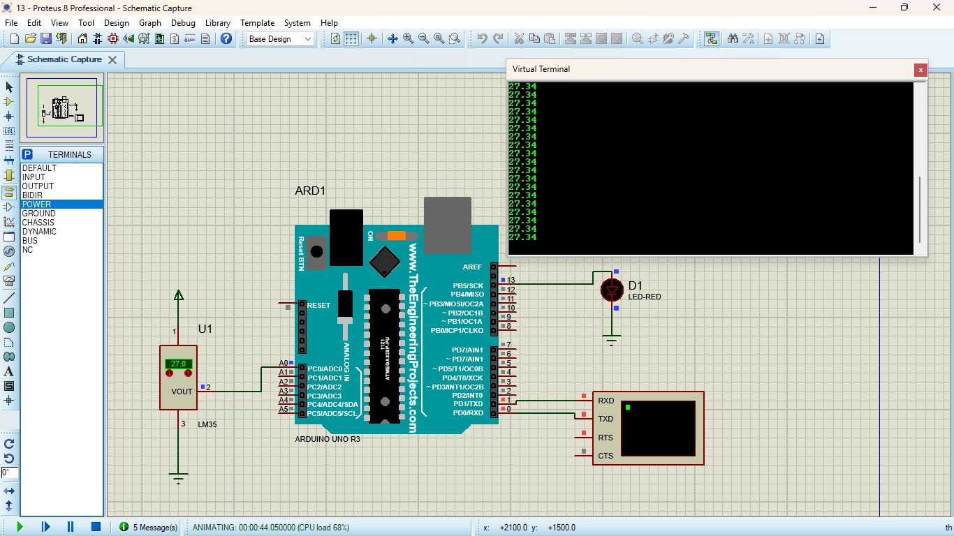

**RESULT:**

Thus the program has been successfully verified and executed.

**Exp No: 14**

# AIM:

# GAS SENSOR MQ-2 IN PROTEUS USING ARDUINO

To write an Embedded C program for interfacing Gas Sensor MQ-2 using Arduino Uno and Proteus

**SOFTWARE REQUIRED:**

* Proteus 8 software.
* Arduino IDE software

# CIRCUIT DIAGRAM:

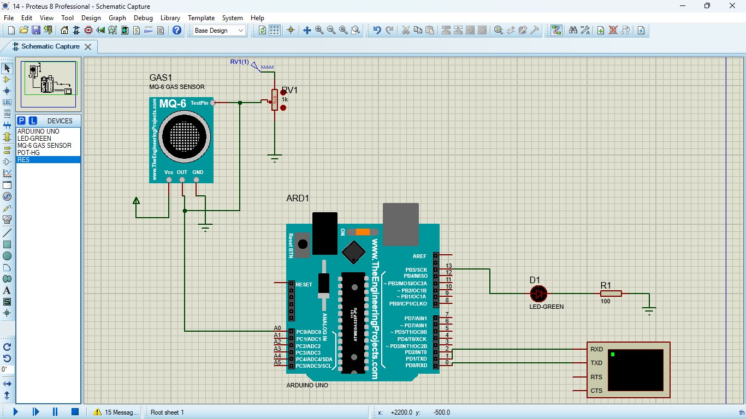

**PROGRAM:**

#define GreenLed 13 #define Sensor A0

void setup(){ pinMode(13,OUTPUT); pinMode(12,OUTPUT); pinMode(A0,INPUT); Serial.begin(9600);

}

void loop() {

int value = analogRead(A0);

Serial.print("Analogic Value coming from the sensor : "); Serial.println(value);

delay(100); if(value>600){ digitalWrite(13,HIGH);

}

else{ digitalWrite(13,LOW);

}

delay(20);

}

**Code for MQ6 sensor:**

int mq6Pin = A0; // MQ-5 analog pin connected to A0

void setup() { Serial.begin(9600);

}

void loop() {

int sensorValue = analogRead(mq5Pin); Serial.print("MQ5 Sensor Value: "); Serial.println(sensorValue); delay(1000); // 1-second delay

}

# OUTPUT:

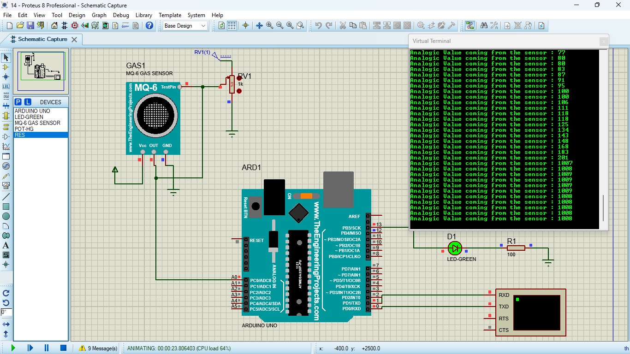

**RESULT:**

Thus the program has been successfully verified and executed.

**Exp No: 15**

# AIM:

# ULTRASONIC SENSOR IN PROTEUS USING ARDUINO

To write an Embedded C program for interfacing Ultrasonic Sensor using Arduino Uno and Proteus

**SOFTWARE REQUIRED:**

* Proteus 8 software.
* Arduino IDE software

# CIRCUIT DIAGRAM:

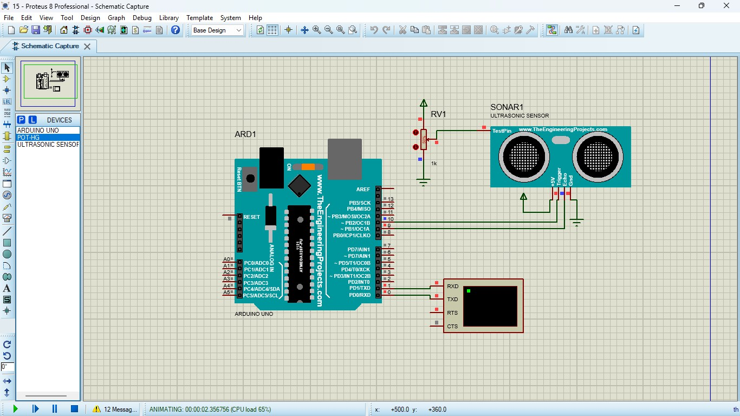

**PROGRAM:**

// Program Sketch int trig = 10; int echo = 9; long duration; int cm;

void setup() {

// put your setup code here, to run once: pinMode(trig, OUTPUT); pinMode(echo,INPUT); Serial.begin(9600);

}

void loop() {

// Sketch to calculate ultrasonic distance digitalWrite(trig, LOW); delayMicroseconds(10); digitalWrite(trig, HIGH); delayMicroseconds(10);

digitalWrite(trig, LOW); delayMicroseconds(10); duration = pulseIn(echo, HIGH); cm = (duration/2) * 0.034;

// Print Value on Serial Monitor Serial.print(" Distance = "); Serial.print(cm); Serial.println(" cm");

}

# OUTPUT:

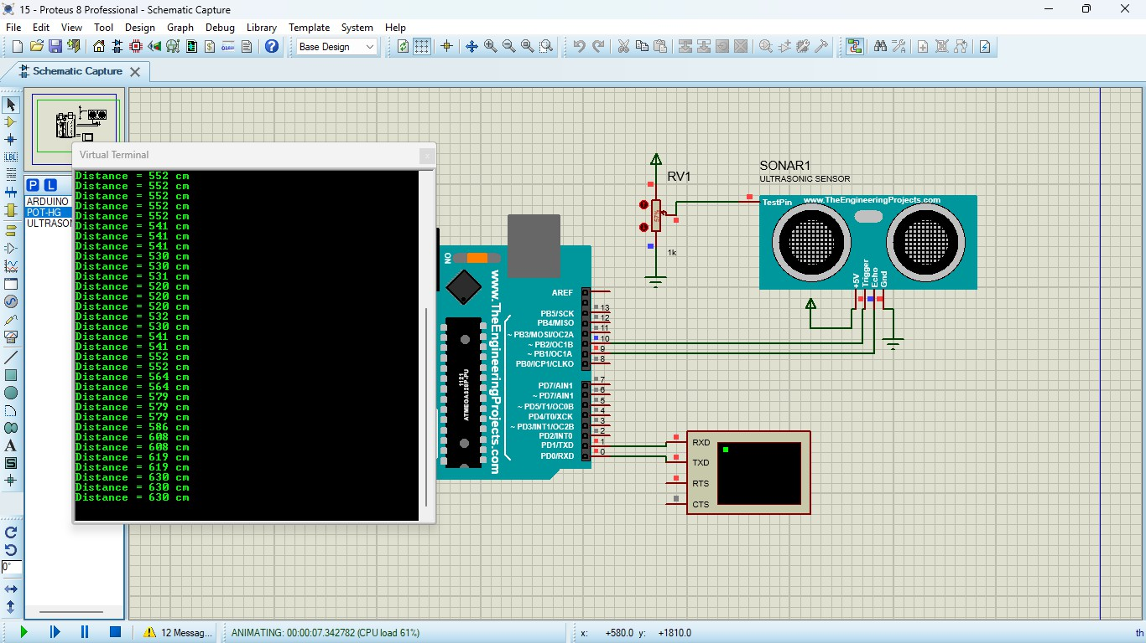

**RESULT:**

Thus the program has been successfully verified and executed.

**Exp No: 16**

# AIM:

# PIR SENSOR IN PROTEUS USING ARDUINO

To write an Embedded C program for interfacing PIR Sensor using Arduino Uno and Proteus

**SOFTWARE REQUIRED:**

* Proteus 8 software.
* Arduino IDE software

# CIRCUIT DIAGRAM:

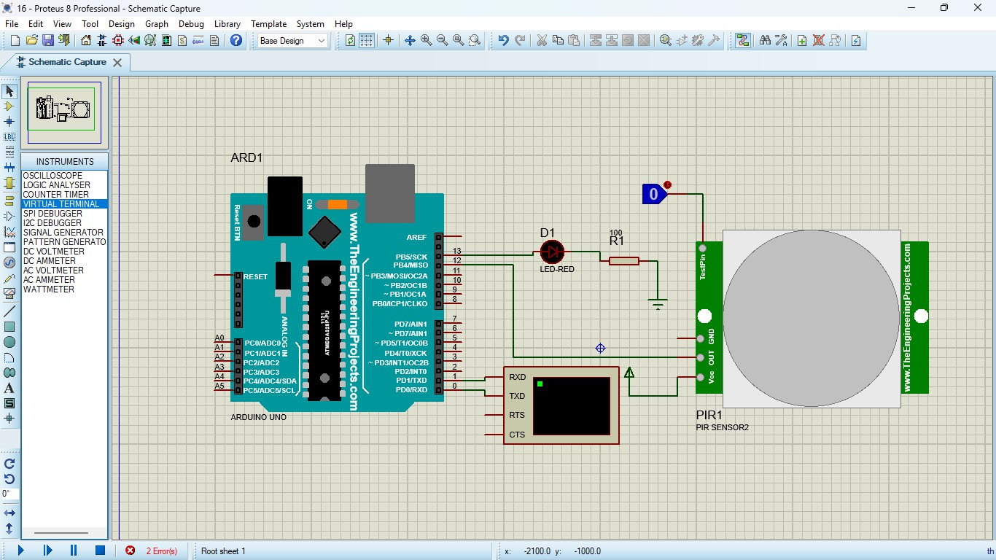

**PROGRAM:**

int Status = 13; // Digital pin D6 int sensor = 12; // Digital pin D7 void setup() { Serial.begin(9600);

pinMode(sensor, INPUT); // declare sensor as input pinMode(Status, OUTPUT); // declare LED as output

}

void loop() {

long state = digitalRead(sensor); Serial.println(state);

if(state == HIGH) { digitalWrite (Status, HIGH);

Serial.println("Motion detected!"); delay(1000);

}

else {

digitalWrite (Status, LOW);

Serial.println("Motion absent!"); delay(1000);

}

}

# OUTPUT:

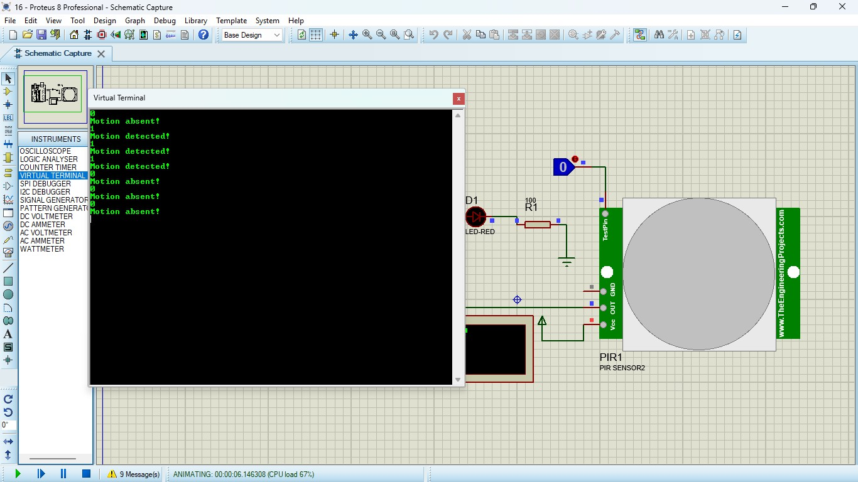

**RESULT:**

Thus the program has been successfully verified and executed.

**Exp No: 17**

# EMBEDDED C PROGRAM TO MULTIPLY TWO 16-BIT BINARY NUMBERS AIM:

To write an Embedded C program to multiply two 16-bit numbers using Keil software

**SOFTWARE REQUIRED:**

* Keil

**Program:**

#include <reg51.h> void main()

{

while (1)

{

unsigned int num1, num2; unsigned long int product; num1 = 0x2222; num2 = 0xBBBB;

product = (unsigned long int)num1 * num2; P0= product &0xff; P1= (product & 0xff00)>>8;

P2 =(product & 0xff0000)>>16; P3 =(product & 0xff000000)>>24;

}

}

# OUTPUT:

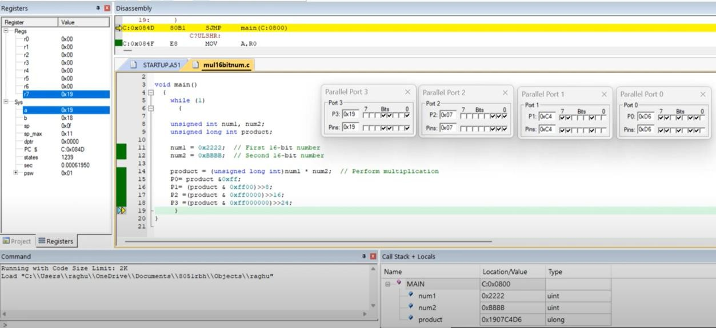

**RESULT:**

Thus the program has been successfully verified and executed.

**Exp No: 18**

# EMBEDDED C PROGRAM TO FIND THE SUM OF FIRST 10 INTEGER NUMBERS AIM:

To write an Embedded C program to find the sum of first 10 integer numbers using Keil software

**SOFTWARE REQUIRED:**

* Keil

# PROGRAM:

#include <reg51.h> void main ( )

{

unsigned char sum=0; unsigned char i; for (i=1; i<=10; i++)

{

sum = sum + i;

}

ACC=sum; P0=sum;

}

# OUTPUT:

1+2+3+4+5+6+7+8+9+10 = 55 (0x37) in Hexadecimal

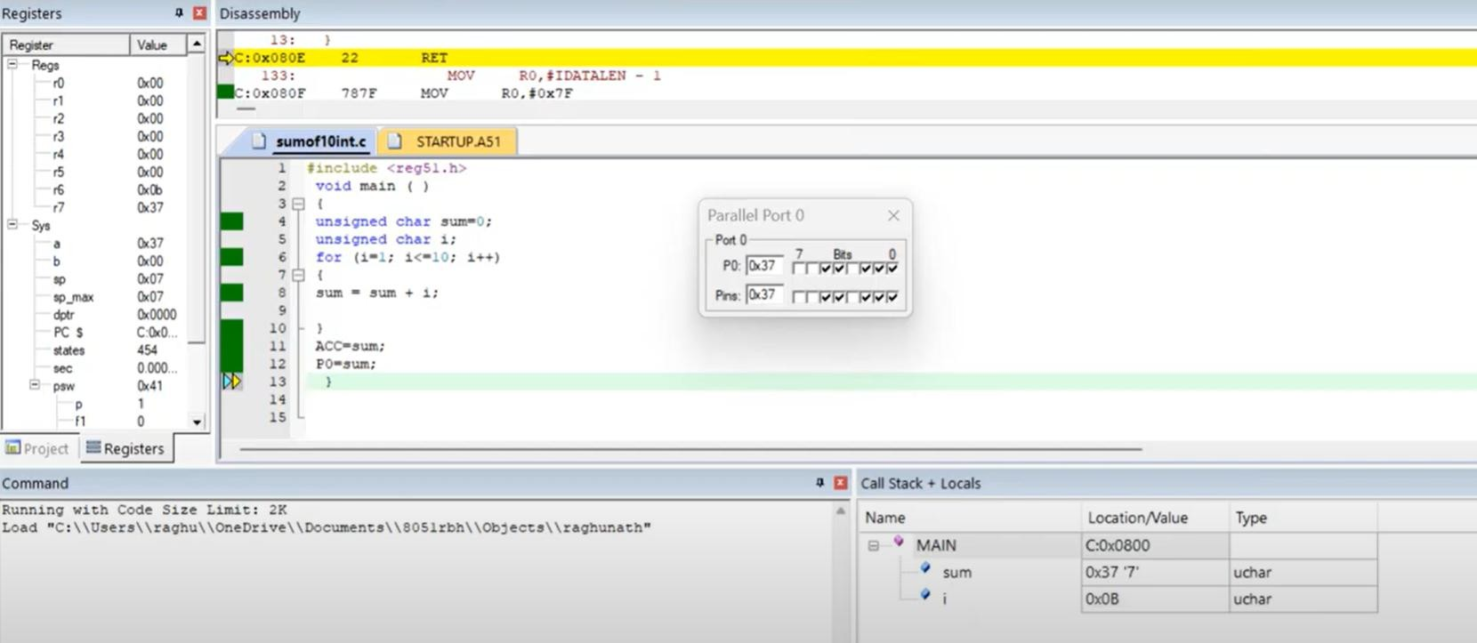

# RESULT:

Thus the program has been successfully verified and executed.

**Exp No: 19**

# EMBEDDED C PROGRAM TO FIND FACTORIAL OF A GIVEN NUMBERS AIM:

To write an Embedded C program to find factorial of a given numbers using Keil software.

**SOFTWARE REQUIRED:**

* Keil

# PROGRAM:

#include <reg51.h> #include <stdio.h> void main()

{

unsigned int i;

unsigned char num = 12; // The number to find the factorial of unsigned long factorial = 1;

for ( i = 1; i <= num; i++)

{

factorial = factorial*i;

}

P0= factorial;

P1= (factorial & 0xff00) >>8; P2= (factorial & 0xff0000) >>16; P3= (factorial & 0xff000000) >>24;

}

# OUTPUT:

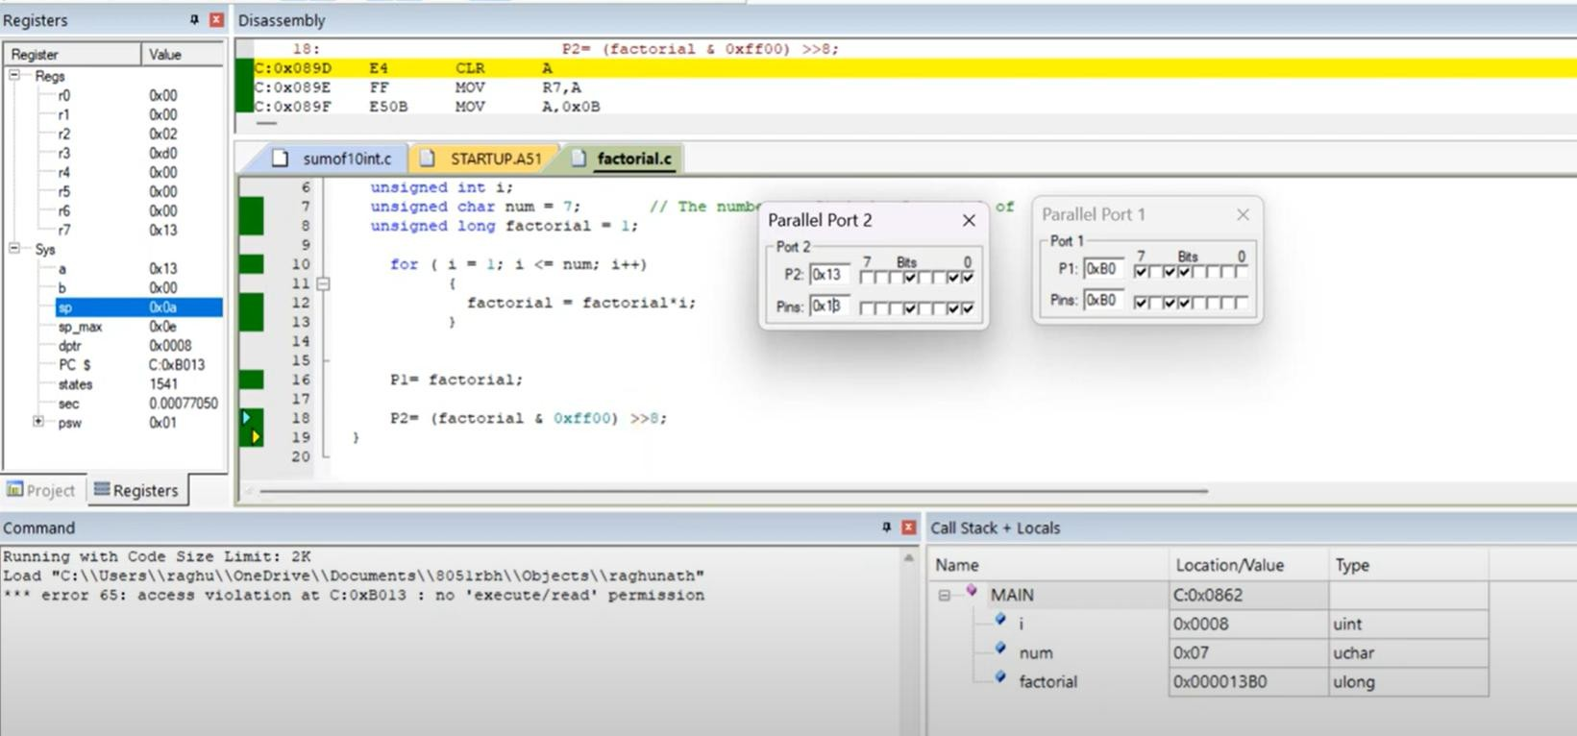

**RESULT:**

Thus the program has been successfully verified and executed.

**Exp No: 20**

# EMBEDDED C PROGRAM TO ADD AN ARRAY OF 16-BIT NUMBERS AND STORE THE 32-BIT RESULT IN INTERNAL RAM

**AIM:**

To write an Embedded C program to add an array of 16-bit numbers and store the results in internal RAM using Keil software.

**SOFTWARE REQUIRED:**

* Keil

# PROGRAM:

#include <reg51.h> void main()

{

unsigned int i, array[5] = { 0x1111, 0x2222, 0x8888, 0x4444, 0xABCD }; unsigned long sum

= 0;

for (i = 0; i < 5; i++)

{

sum =sum + array[i];

}

P0 = sum & 0xFF;

P1= (sum & 0xff00)>>8; P2=(sum & 0xFF0000)>>16;

}

**INPUT:**

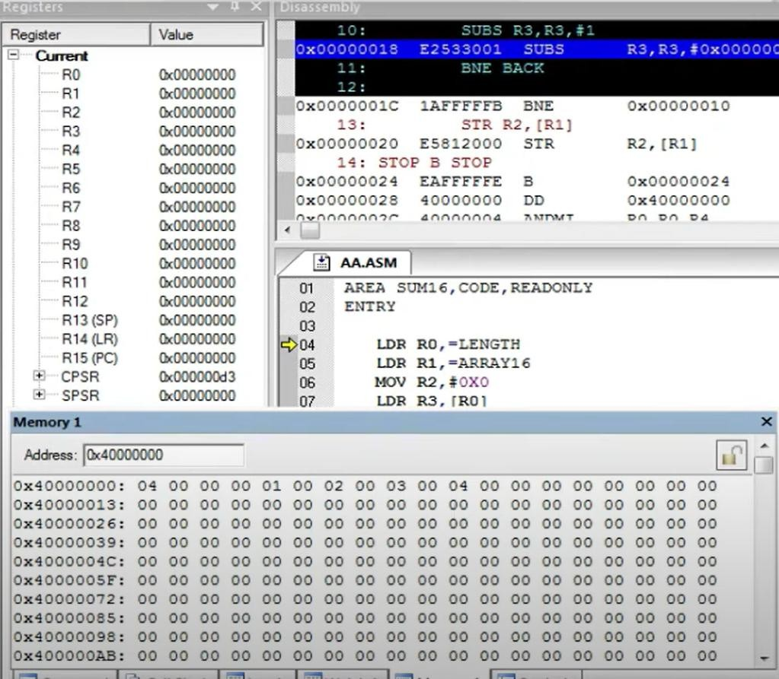

**OUTPUT:**

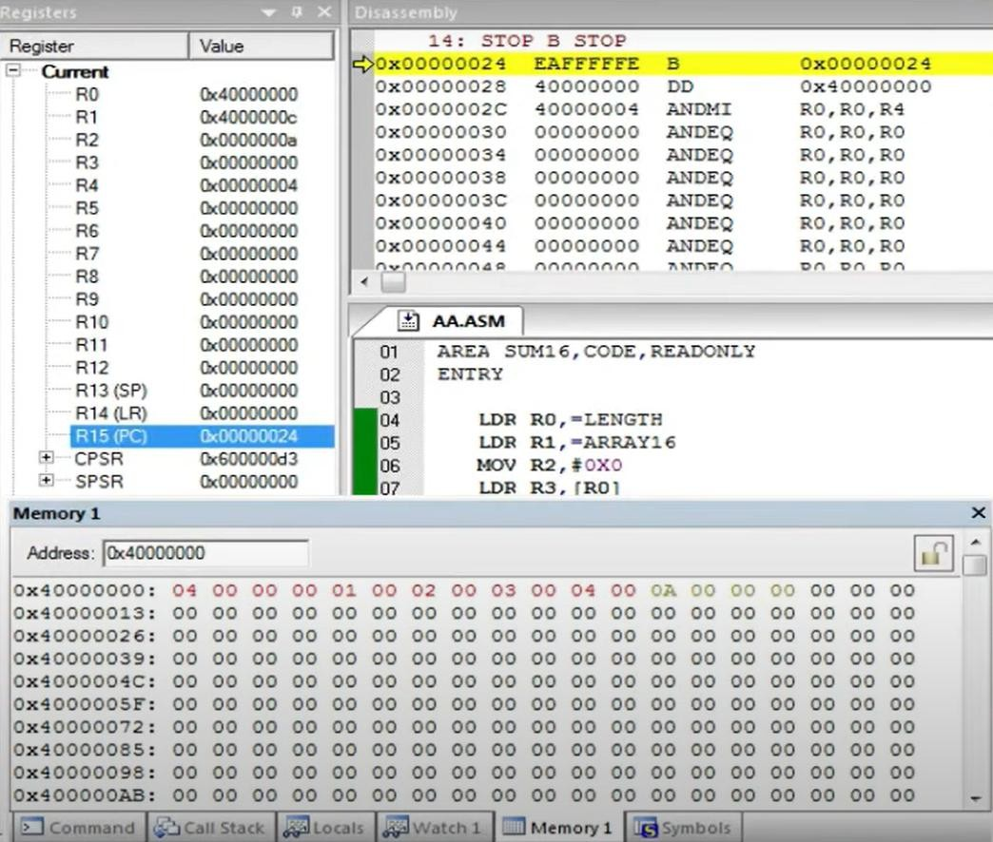

**RESULT:**

Thus the program has been successfully verified and executed.

**Exp No: 21**

# EMBEDDED C PROGRAM TO DISPLAY “HELLO WORLD” MESSAGE

**AIM:**

To write an Embedded C program to display “HELLO WORLD” message using Keil software.

**SOFTWARE REQUIRED:**

* Keil sofware

**Program:**

#include <reg51.h> #include <stdio.h> void main (void)

{

SCON = 0x50; /* SCON: mode 1, 8-bit UART, enable rcvr */ TMOD = 0x20;

/* TMOD: timer 1, mode 2, 8-bit reload */ TH1 = 0xFD; /* TH1: reload value for 9600 baudrate */

TR1 = 1; /* TR1: timer 1 run */

TI = 1; /* TI: set TI to send first char of UART */ while (1)

{

printf ("Hello World ! \n ");

}

}

# OUTPUT:

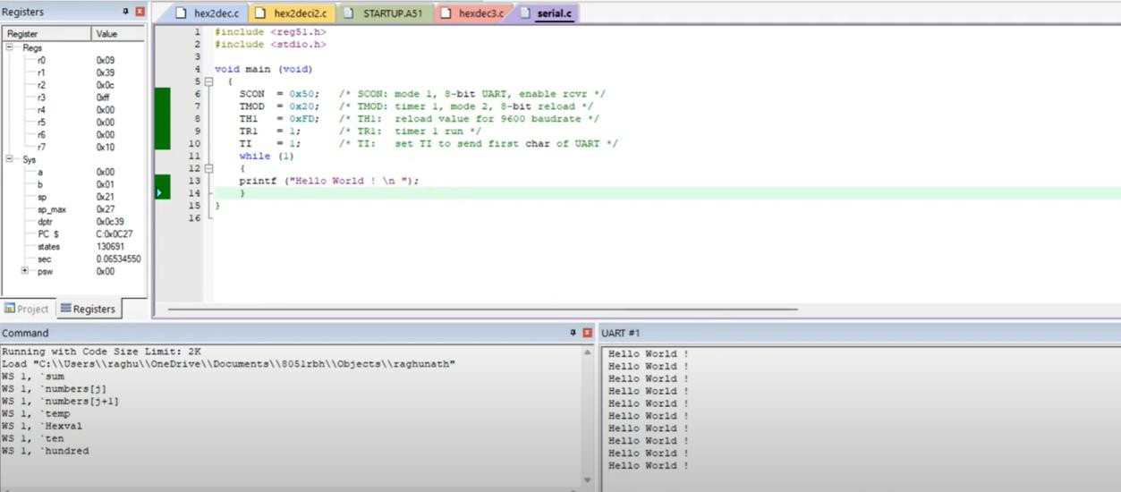

**RESULT:**

Thus the program has been successfully verified and executed.

**Exp No: 22**

# EMBEDDED C PROGRAM TO CONVERT THE HEXADECIMAL DATA 0XCFH TO DECIMAL AND DISPLAY THE DIGITS ON PORTS P0, P1 AND P2

**AIM:**

To write an Embedded C program to convert Hexadecimal numbers into Decimal and display the digits on ports using Keil software.

**SOFTWARE REQUIRED:**

* Keil software

# PROGRAM:

# include <reg51.h> void main (void)

{

unsigned char hexa=0xFF; unsigned char hundreds, tens, units; hexa=hexa/10; P0=B;

units=B;

hexa = hexa/10; hundreds=ACC; tens=B; P1=B; P2=ACC;

while(1);

}

# OUTPUT:

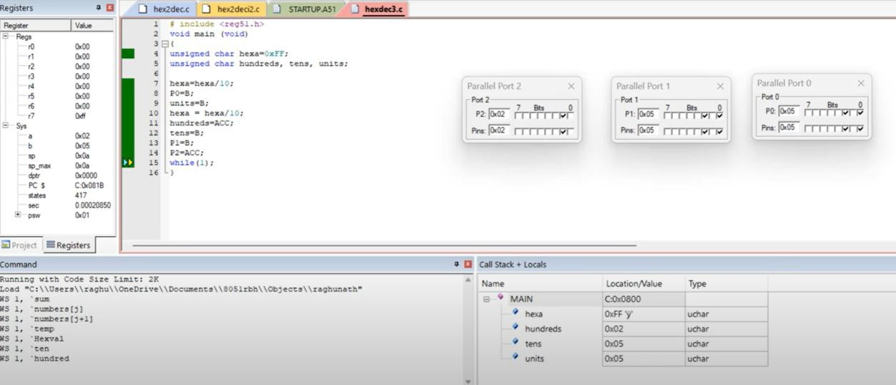

**RESULT:**

Thus the program has been successfully verified and executed.

**Exp No: 23**

# AIM:

# STUDY OF ARM PROCESSOR

To study the architecture and working of an ARM processor.

# COMPONENT REQUIRED:

* ARM LPC2148

# THEORY:

ARM is a family of instruction set architectures for computer processors based on a reduced instruction set computing (RISC) architecture developed by British company ARM Holdings. A RISC-based computer design approach means ARM processors require significantly fewer transistors than typical processors in average computers. This approach reduces costs, heat and power use. These are desirable traits for light, portable, battery-powered devices—including smartphones, laptops, tablet and notepad computers), and other embedded systems. A simpler design facilitates more efficient multi-core CPUs and higher core counts at lower cost, providing higher processing power and improved energy efficiency for servers and supercomputers.

**Features of LPC214x Series Controllers:**

* 8 to 40 kB of on-chip static RAM and 32 to 512 kB of on-chip flash program memory.128 bit wide interface/accelerator enables high speed 60 MHz operation.
* In-System/In-Application Programming (ISP/IAP) via on-chip boot-loader software. Single flash sector or full chip erase in 400 ms and programming of 256 bytes in 1ms.
* Embedded ICE RT and Embedded Trace interfaces offer real-time debugging with the on-chip Real Monitor software and high speed tracing of instruction execution.
* USB 2.0 Full Speed compliant Device Controller with 2 kB of endpoint RAM. In addition, the LPC2146/8 provides 8 kB of on-chip RAM accessible to USB by DMA.
* One or two (LPC2141/2 vs. LPC2144/6/8) 10-bit A/D converters provide a total of 6/14analog inputs, with conversion times as low as 2.44 us per channel.
* Single 10-bit D/A converter provides variable analog output.
* Two 32-bit timers/external event counters (with four capture and four compare channels each), PWM unit (six outputs) and watchdog.
* Low power real-time clock with independent power and dedicated 32 kHz clock input.
* Multiple serial interfaces including two UARTs (16C550), two Fast I2C-bus (400 kbit/s), SPI and SSP with buffering and variable data length capabilities.
* Vectored interrupt controller with configurable priorities and vector addresses.
* Up to 45 of 5 V tolerant fast general purpose I/O pins in a tiny LQFP64 package.
* Up to nine edge or level sensitive external interrupt pins available.
* On-chip integrated oscillator operates with an external crystal in range from 1 MHz to30 MHz and with an external oscillator up to 50 MHz.
* Power saving modes include Idle and Power-down.
* Individual enable/disable of peripheral functions as well as peripheral clock scaling for additional power optimization.
* Processor wake-up from Power-down mode via external interrupt, USB, Brown-Out Detect (BOD) or Real-Time Clock (RTC).
* Single power supply chip with Power-On Reset (POR) and BOD circuits – CPU operating voltage range of 3.0 V to 3.6 V (3.3 V ± 10 %) with 5 V tolerant I/O pads.

LPC2148 needs the following hardware to work properly:

* Power Supply
* Crystal Oscillator
* Reset Circuit
* RTC crystal oscillator
* UART

*Power Supply*

LPC2148 works on 3.3 V power supply. LM 117 can be used for generating 3.3 V supply. However, basic peripherals like LCD, ULN 2003 (Motor Driver IC) etc. works on 5V. So AC mains supply is converted into 5V using below mentioned circuit and after that LM 117 is used to convert 5V into 3.3V.

*Reset Circuit*

Reset button is essential in a system to avoid programming pitfalls and sometimes to manually bring back the system to the initialization mode. MCP 130T is a special IC used for providing stable RESET signal to LPC 2148.

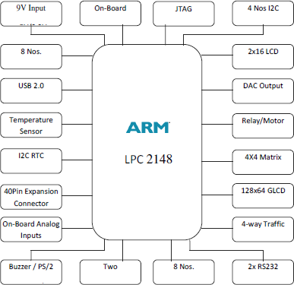

**Figure - 3.1:** ARM Processor

*Flash Programming Utility*

NXP Semiconductors produce a range of Microcontrollers that feature both on-chip. Flash memory and the ability to be reprogrammed using In-System Programming technology.

**On-board Peripherals**

* 8-Nos. of Point LED’s (Digital Outputs)
* 8-Nos. of Digital Inputs (Slide Switch)
* 2 Lines X 16 Character LCD Display
* I2C Enabled 4 Digit Seven-Segment Display
* 128x64 Graphical LCD Display
* 4 X 4 Matrix keypad
* Stepper Motor Interface
* 2 Nos. Relay Interface
* Two UART for Serial Port Communication through PC
* Serial EEPROM
* On-chip Real Time Clock with Battery Backup
* PS/2 Keyboard Interface (Optional)
* Temperature Sensor
* Buzzer (Alarm Interface)
* Traffic Light Module (Optional)

**Pin Configuration**

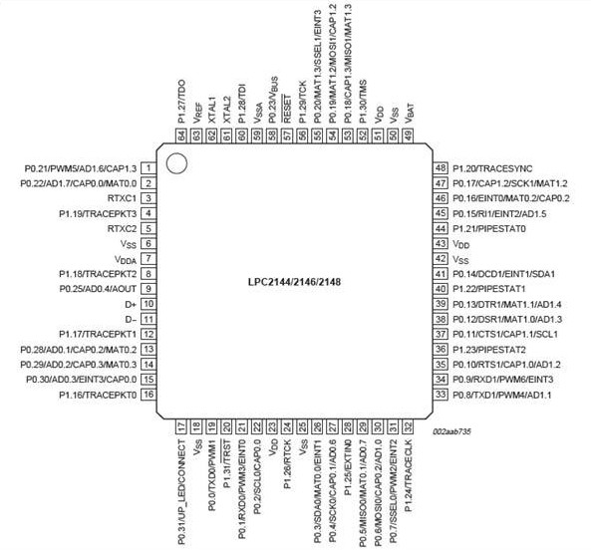

**Result:**

The ARM processor has been studied successfully.

**Exp No: 24**

# BLINKING LEDS USING SOFTWARE DELAY ROUTINE IN LPC2148 KIT

**AIM:**

To write and execute a C program to blink LEDs using software delay routine in LPC

2148 kit

# APPARATUS REQUIRED:

Keil uVision5 Software Philips Flah Programmer LPC 2148 kit

# PROGRAM:

#include "lpc214x.h"

void delay (unsigned int k); void main(void)

{

IODIR0 = 0xFFFFFFFF; //Configure Port0 as output Port

PINSEL0 = 0; //Configure Port0 as General Purpose IO while(1)

{

IOSET0 = 0x0000ff00; //Set P0.15-P0.8 to '1'

delay(1000); //1 sec Delay

IOCLR0 = 0x0000ff00; //Set P0.15-P0.8 to '0'

delay(1000); //1 Sec Delay

}

}

//Delay Program

//Input - delay value in milli seconds void delay(unsigned int k)

{

unsigned int i,j; for (j=0; j<k; j++)

for(i = 0; i<=800; i++);

}

**OUTPUT:** LEDs P0.15-P0.8 are blinking

# RESULT:

Thus the C program to blink LEDs using software delay routine was written and executed in LPC 2148 kit

**Exp No: 25**

# PROGRAM TO READ THE SWITCH AND DISPLAY IN THE LEDS USING LPC2148 KIT

**AIM:**

To write and execute C program to read the switch and display in the LEDs using

LPC2148 kit

# APPARATUS REQUIRED:

Keil uVision5 Software Philips Flah Programmer LPC 2148 kit

# PROGRAM:

#include "lpc214x.h" int main(void)

{

unsigned int sw_sts;

IODIR0 = 0x0000ff00; //Configure Port0

PINSEL0 = 0; //Configure Port0 as General Purose IO while(1)

{

sw_sts = IOPIN0;

IOSET0 = 0x0000ff00; //Set P0.15-P0.8 to '1'

IOCLR0 = sw_sts >> 8; //Set P0.15-P0.8 to '0'

}

}

**OUTPUT:** LEDs P0.15-P0.08 displayed the bits entered in the switches

# RESULT:

Thus C program was written read the switch and display in the LEDs using LPC2148 kit

**Exp No: 26**

# DISPLAY A NUMBER IN SEVEN SEGMENT LED IN LPC2148 KIT

**AIM:**

To write and execute C program to display a number in seven segment LED in

LPC2148 kit

# APPARATUS REQUIRED:

Keil uVision5 Software Philips Flah Programmer LPC 2148 kit

# PROGRAM:

//SEVEN SEGMENT LED DISPLAY INTERFACE IN C

/* Program to Count 0-9 and Display it in 7 segment Display (MUX) DS4

* Display Select DS3 ==> "P0.13" Enable --> '0', Disable --> '1'
* Display Select DS4 ==> "P0.12" Enable --> '0', Disable --> '1'

*/

/* Segment Connection Display 1 & 2 Enable --> '1', Disable --> '0'

* ​

|  |  |  |  |  |  |  |
| --- | --- | --- | --- | --- | --- | --- |
| * MSB |  |  |  |  |  | LSB |
| * Dp | G | F | E | D C | B | A |

* P0.23 P0.22 P0.21 P0.20 P0.19 P0.18 P0.17 P0.16

* 0 0 0 0 0 1 1 0 --> 6 => '1'

* */

#include <LPC214X.H>

#define DS3 1<<13 // P0.13

#define DS4 1<<12 // P0.12

#define SEG_CODE 0xFF<<16 // Segment Data from P0.16 to P0.23

unsigned char const seg_dat[]={0x3F, 0x6, 0x5B, 0x4F, 0x66, 0x6D, 0x7D, 0x7, 0x7F, 0x67};

void delayms(int n)

{

int i,j; for(i=0;i<n;i++)

{for(j=0;j<5035;j++) //5035 for 60Mhz ** 1007 for 12Mhz

{;}

}

}

int main (void)

{

unsigned char count;

PINSEL0 = 0; // Configure Port0 as General Purpose IO => P0.0 to P0.15 PINSEL1 = 0; // Configure Port0 as General Purpose IO => P0.16 to P0.31

IODIR0 = SEG_CODE | DS3 | DS4; //Configure Segment data & Select signal as output IOSET0 = SEG_CODE | DS3 ; //Disable DS3 display

IOCLR0 = DS4; //Enable DS4 Display count = 0; //Initialize Count

//Display Count value IOCLR0 = SEG_CODE;

IOSET0 = seg_dat[count]<<16;

while(1)

{

delayms(1000); //1 sec delay count++; //Increment count if(count>9) count=0; //Limit 0-9

//Display Count value IOCLR0 = SEG_CODE;

IOSET0 = seg_dat[count]<<16;

}

}

**OUTPUT:** 7-Segment display counting from 0 to 9

# RESULT:

Thus C program, was written and executed to display a number in seven segment LED in LPC2148 kit

**Exp No: 27**

# SERIAL TRANSMISSION AND RECEPTION USING ON-CHIP UART IN LPC2148 KIT

**AIM:**

To write and execute C program for serial transmission and reception using on-chip

UART in LPC2148 kit.

# APPARATUS REQUIRED:

Keil uVision5 Software Philips Flah Programmer LPC 2148 kit

# PROGRAM:

#include <lpc214x.h> void UART0_Init(void)

{

PLL0CON = 0; PLL0FEED=0xAA; PLL0FEED=0x55; VPBDIV = 1;

// Fpclk = 12.000.000 MHz

// DLM,DLH = Fpclk / (19200*16) = 39 = 0x27

PINSEL0 |= 0x5; // Select UART0 RXD/TXD U0FCR = 0; // Disable FIFO's

U0LCR = 0x83; // 8N1, enable Divisor latch bit

U0DLL = 0x27; // baud rate fixed to 19200 @ PCLK = 12 Mhz U0DLM = 0;

U0LCR = 3; // Disable Divisor latch bit

}

/* */

/* Function to send one char. to Serial Port */ void sout(unsigned char dat1)

{

while(!(U0LSR & 0x20));//Wait for Tx Buffer Empty U0THR = dat1; //Send to UART1

}

/* */

int main (void)

{ int dat; UART0_Init(); do

{

if(U0LSR & 1) /* Check for RDR (Receiver Data Ready)command */

{

dat = U0RBR;// Receive Data from Srial Port sout(dat); // Send Data to Srial Port

}

}while(1);

}

**OUTPUT:** Data was serially transmitted

# RESULT:

Thus a C program was Written and executed for serial transmission and reception using on- chip UART in LPC2148 kit.

**Exp No: 28**

# ACCESS AN INTERNAL ADC AND DISPLAY THE BINARY OUTPUT IN LEDS IN LPC2148 KIT

**AIM:**

To write and execute C program for accessing an internal ADC and display the binary

output in LEDS in LPC2148 kit.

# APPARATUS REQUIRED:

Keil uVision5 Software Philips Flah Programmer LPC 2148 kit

# PROGRAM:

#include <LPC214X.H>

#define LEDS 0xFF<<8 //LED => P0.8 to P0.15

/////////////////////////////////////////

/*--- ADC Signal Declaration */

///////////////////////////////////////// #define AD0_1 1<< 24

#define CLK_DIV 1<<8

#define PDN 1<<21

#define SOC 1<<24

#define BURST 1<<16

#define DONE 1<<31

/* */

//Delay Program

//Input - delay value in milli seconds void delay(unsigned int k)

{

unsigned int i,j; for (j=0; j<k; j++)

for(i = 0; i<=800; i++);

}

/* */

void adc_init()

{

unsigned long int ADC_CH;

ADC_CH = 0 | 1 << 1; //Channel AD0.1

AD0CR = SOC | PDN | CLK_DIV | ADC_CH | BURST ;

}

/* */

unsigned int adc_read( unsigned char channel)

{

unsigned int aval; unsigned long int val;

if (channel == 1) val = AD0DR1; else if (channel == 2) val = AD0DR2; else if (channel == 3) val = AD0DR3;

val = val >> 6;

val = val & 0x3FF; aval = val;

return (aval);

}

/* */

//////////////////////////

/*----Main Program */

////////////////////////// int main(void)

{

unsigned int tp1;

IODIR0 = LEDS; //Configure Port0 as output Port PINSEL0 = 0; //Configure Port0 as General Purpose IO PINSEL1 = 0 | AD0_1; // Enable AD0.1

adc_init(); //Initialise on-chip ADC

do

{ tp1 = adc_read(1); // Channel AD0 0.1

tp1 = tp1 >> 2; // ADC 10 bit But LED 8bit, Truncate lsb 2 bits IOSET0 = LEDS; //Switch OFF all LEDS

IOCLR0 = tp1 << 8; //Set VAlue delay(1000);

}while(1);

}

**OUTPUT:** The Potentiometer knob was adjusted to generate Analog input and Digital display is observed

# RESULT:

Thus C program was Written and executed for accessing an internal ADC and display the binary output in LEDS in LPC2148 kit.